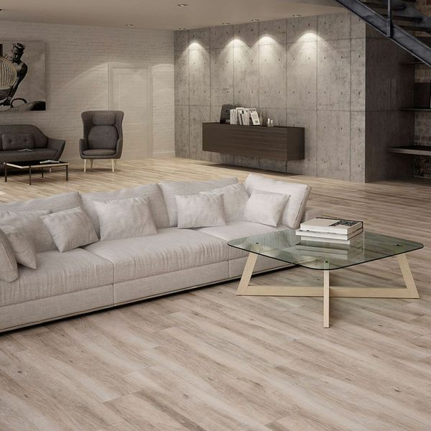**Parlor Fallow Walnut Wood Effect Tiles:**

## **Product Description**

Want to welcome that warming, soothing, natural look into your home this season? These Fallow Walnut Tiles are exactly what the doctor ordered. These plank shaped tiles have a realistic wood effect design; complete with knots and woodgrain. They're made from durable porcelain tiles and can be used on floor spaces throughout your home. They belong to our selection of Parlor Wood Effect Tiles. For an attractive floor display, try creating a Herringbone parquet style pattern.

## **Product INFO**

* Product ID 14698
* Tiles Per SQM 3.5765379113019
* Sale by Per SQM
* Size 233x1200x10mm
* Weight 6.24 KG
* Material Type Porcelain
* Finish Matt
* Colour Beige/Ivory
* Suitability Floors
* Grade 4
* Rectified Edge No
* Underfloor Heating Yes
* Document [View Layout Designs](https://m2.wallsandfloors.co.uk/media/amasty/amfile/attach/fallow-walnut-tiles-parlor-wood-effect-tiles-.pdf)
* Thickness (mm) 10